**Observation**

Inspection was undertaken at the subject property to which the following was noted:

## Observed Damage

1. Within the internal areas of the dwelling, the Insured has claimed that the carpet flooring has been exhibiting ongoing dampness and mould. **Images 2 – 4**
2. Across the external masonry walls, we noted several locations of step-cracking along the brickwork mortar joint, lateral shifting and rotation of the brickwork, mainly propagating from wall corners and the corners of openings. **Images 5 – 10**

## Assessment of Cracking to Brickwork

### Foundation Reactivity & General Building Movement

1. In prefacing the assessment of the observed damage, we refer to *AS 2870 – Residential Slabs and Footings* which acknowledges that foundation movement and reactivity naturally occurs on nearly all sites and that it is impracticable to design a footing system that will protect the building from movement under all circumstances.
2. We refer to the *CSIRO publication, BTF 18 – Foundation Maintenance and Footing Performance: A Homeowner’s Guide*, which clearly indicates that buildings can and often move as a result of one or more issues in the foundation soil, namely relating to differential settlement, erosion, saturation, seasonal wetting and drying.
3. A copy of this *CSIRO* publication is attached as ***Appendix A*** of this report.
4. In saying this, general foundation reactivity and ground movement occurs as a result of the moisture content alteration within the foundation material, which shrinks upon drying and swells upon wetting over multiple courses of rainfall, causing heaving and shifting within the footings gradually and progressively over an extended period of time in years.
5. We note that the property is supported on timber floor bearers and joists which sit on perimeter brick dwarf walls and isolated brick piers.
6. In saying this, we advise that such aged foundation system is particularly susceptible to movement due to its non-homogenous configuration compared to tied systems such as a concrete raft slab.
7. On the basis of the above, given the age and construction of the property, on-going and cyclic foundation reactivity and ground movement is always expected to occur, to which building movement and cracking about locations of high stress concentrations is ultimately expected over time.
8. Furthermore, we refer to Bureau of Metrology (BOM) website to review rainfall periods at the nearest weather station located at Moss Vale AWS (approximately 5.4km away) over the period of last six (6) years, from 2017 to 2022, in **Figure 2** below:

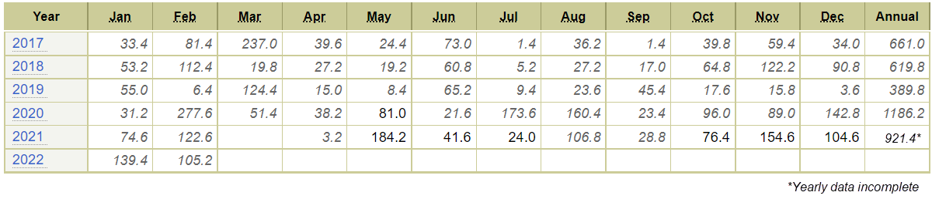

Figure 2 – Historical Monthly Rainfalls from 2017 to 2022

1. From the above, we note that the recorded annual rainfalls in 2017, 2018 and 2019 are within 400mm to 660mm, whilst the recorded annual rainfalls in 2020 and 2021 are in excess of 920mm, which is nearly 50% greater.
2. The record high rainfalls over the last two (2) years are consistent with the ***La Niña*** weather phenomenon which occurs roughly every three to seven years, causing extreme rainfalls.
3. In saying this, Australia has been in a La Niña period from 2020 and currently into 2022, which follows a severe drought period from 2017 – 2019 in many parts of the country.
4. In saying this, the foundation materials within the subject site have experienced generally dry periods over 2017 – 2019, followed by excessively wet periods since 2020.
5. As such, the higher degree of fluctuation in foundation material moisture content over the last six (6) years has resulted in more severe foundation reactivity and movement resulting in more prominent movement and damage within the building fabrics.
6. On the above basis, we consider the increase in received rainfall from 2020 to current to be the dominant factor in contributing to building movement as claimed rather than any defined storm event.
7. In saying this, considering that the general foundation reactivity and ground movement is an ongoing mechanism, the observed cracking and movement will always be expected to reoccur.

### Inadequate Subfloor Drainage

1. At the time of our inspection, we noted that the subfloor was significantly inundated. **Images 11 & 12**
2. Given that only light rainfall had occurred around the period of our inspection, the observed ponding water is indicative of inadequate subfloor drainage provisions.
3. In particular, we noted the subfloor to be relatively flat in grade, with evident divots which facilitate such water ponding.
4. Given the considerable age of the property, we envisage that its construction pre-dates the inception of the current *National Construction Code Building Code of Australia 2019 (NCC BCA 2019)* and Australian Standards, however, we only refer to such codes for explanatory purposes on the causation and mechanism of the observed damage.
5. In accordance with *NCC BCA 2019*, the ground beneath suspended floors must be graded so that the area beneath the building is above the adjacent external finished ground level and surface water is prevented from ponding under the building.
6. An illustrative diagram taken from *NCC BCA 2019* has been provided in ***Figure 3***.

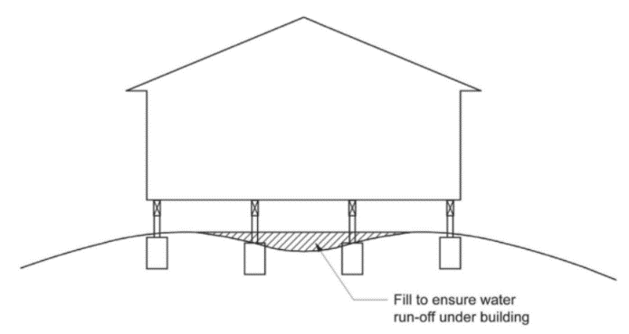

***Figure 3 – Grading of Ground Under Suspended Floors***

1. We noted similar grading issues with the external surrounding soil, which is located higher than the subfloor ground level, to which the subfloor would be inherently susceptible to surface water ingress during rainfall over time.
2. On the basis of the above, in our opinion, water ingress is easily able to occur into the subfloor area during general rainfall over time and, in absence of adequate drainage provisions, contributes to the ongoing inherent foundation reactivity.

### Omission of Cavity Flashing and Weepholes

1. Moreover, we noted no evidence of visible weepholes or a cavity flashing along the external masonry walls. **Images 13 & 14**
2. We refer to *AS 4773.2:2015 Masonry in small buildings* – Construction, which outlines the following requirements for masonry veneer construction:
   1. Weepholes are required at 1200mm maximum centres at the base of the wall cavity, to enable the discharge of any contained moisture.
   2. Cavity flashings are required to extend the full width and be visible at the face of the wall including after rendering or any other applied coatings, to facilitate the full discharge of moisture out the face of the wall and mitigate the risk of possible backtrack along the underside.
3. On the basis of the above, any entrapped moisture within the wall cavity is unable to effectively discharge out the face of the masonry veneer walls and rather, leads to the possibility of permeating through the internal linings or down into the subfloor.
4. In saying this, we consider such construction issues to be a contributing factor to the experienced water ingress into subfloor, which in turn, exacerbates the ongoing inherent foundation reactivity.

### Inadequate Downpipe Connections

1. Further from our external inspection, we noted four (4) roof downpipes which are not connected to any stormwater lines. **Images 15 – 18**
2. In saying this, the downpipes discharge water directly into the surrounding soil during rainfall.
3. On the basis of the above, in our opinion, the excessive inundation of the soil in such areas exacerbates the moisture fluctuations within the soil over time, which contributes to the ongoing inherent foundation reactivity.

### Tree Root Moisture Suction

1. Moreover, we noted the presence of a large tree directly adjacent to the eastern external wall of the dwelling where the brickwork has shifted and rotated. **Image 19**
2. As outlined within the *CSIRO* publication, we advise that tree roots inherently absorb subterranean moisture which results in drying out of the soil and removal of support from under footings by inducing shrinkage.
3. In saying this, in our opinion, such long-term tree root moisture suction would have exacerbated the inherent moisture fluctuations within the soil over time, contributing to the observed cracks to the masonry walls, to which the level of severity was observed to be greater around the subject area.
4. To this end, in our opinion, the underlying cause of water ingress within the subfloor and cracking to the brickwork is attributable to inherent construction issues and long-term foundation reactivity, and is unrelated to any single storm or other insurable event.

## Assessment of Mould Damage to Carpet Flooring

### Excessive Subfloor Moisture

1. As previously discussed, in absence of adequate subfloor drainage provisions, significant ponding of water occurs over time.
2. In saying this, the flooring would be exposed to high moisture conditions for prolonged periods, to which we envisage would facilitate mould growth across the carpet flooring as claimed by the Insured.

### Omission of Cavity Flashing and Weepholes

1. Furthermore, as previously discussed, we opine that the omission of cavity flashing and weepholes causes entrapped moisture within the wall cavity to permeate through into the internal areas rather than effectively discharging out the face of the masonry veneer walls.
2. In saying this, in our opinion, such long-term moisture permeation is a contributing factor to the experienced mould growth across the carpet flooring.
3. To this end, in our opinion, the underlying cause of mould growth to the internal carpet flooring is attributable to inherent construction issues, and is unrelated to any single storm or other insurable event.

**Discussion**

NA

**Conclusion**

## Assessment of Cracking to Brickwork

In prefacing the assessment of the observed damage, we refer to *AS 2870 – Residential Slabs and Footings* which acknowledges that foundation movement and reactivity naturally occurs on nearly all sites and that it is impracticable to design a footing system that will protect the building from movement under all circumstances.

We refer to the *CSIRO publication, BTF 18 – Foundation Maintenance and Footing Performance: A Homeowner’s Guide*, which clearly indicates that buildings can and often move as a result of one or more issues in the foundation soil, namely relating to differential settlement, erosion, saturation, seasonal wetting and drying.

Furthermore, the property is supported on timber floor bearers and joists which sit on perimeter brick dwarf walls and isolated brick piers. Which is particularly susceptible to movement due to its non-homogenous configuration compared to tied systems such as a concrete raft slab.

On the basis of the above, given the age and construction of the property, **on-going and cyclic foundation reactivity and ground movement is always expected to occur, to which building movement and cracking about locations of high stress concentrations is ultimately expected over time.**

Moreover, we advise that Australia has been in a ***La Niña*** period from 2020 and currently into 2022, which follows a severe drought period from 2017 – 2019 in many parts of the country.

As such, the higher degree of fluctuation in foundation material moisture content over the last six (6) years has resulted in more severe foundation reactivity and movement resulting in more prominent movement and damage within the building fabrics.

On the above basis, **we consider the increase in received rainfall from 2020 to current to be the dominant factor in contributing to building movement as claimed rather than any defined storm event.**

Further from our inspection, we consider the following issues to be contributing factors to the abovementioned ongoing inherent foundation reactivity and subsequent cracking to the external brickwork:

* Inadequate subfloor and site surface drainage provisions, which results in inundation and ponding of water within subfloor, contributing to the ongoing foundation reactivity.
* Omission of cavity flashing and weepholes across the external masonry walls, causing any entrapped moisture within the wall cavity to permeate down into the subfloor, rather than effectively discharge externally, contributing to the ongoing foundation reactivity.
* Unconnected roof downpipes which discharge directly to the surrounding soil, exacerbating soil moisture fluctuations and contributing to the ongoing foundation reactivity
* Long-term tree root growth and soil moisture suction, exacerbating moisture soil fluctuations and removal of support from footings by inducing shrinkage.

To this end, in our opinion, **the underlying cause of water ingress within the subfloor and cracking to the brickwork is attributable to inherent construction issues and long-term foundation reactivity, and is unrelated to any single storm or other insurable event.**

## Assessment of Mould Damage to Carpet Flooring

From our inspection, we consider the following issues to be contributing factors to the experienced mould growth within the carpet flooring:

* In absence of adequate subfloor drainage provisions, significant ponding of water occurs over time, to which the flooring would be exposed to high moisture conditions for prolonged periods, facilitating mould growth over time.
* Omission of cavity flashing and weepholes across the external masonry walls, causing any entrapped moisture within the wall cavity to permeate into the internal areas, rather than effectively discharge externally, contributing to the mould growth.

To this end, in our opinion, **the underlying cause of mould growth to the internal carpet flooring is attributable to inherent construction issues, and is unrelated to any single storm or other insurable event.**